WEB PROGRAMMING

Ma’am Sumaira Mustafa

Muhammad Abdullah Ramzan

21F-9204

BSCS

SECTION C

**Task no. 1:**

**Code:**

<!DOCTYPE html>

<html lang="en">

<head>

    <meta charset="utf-8">

    <title>Task 1</title>

    <meta name="viewport" content="width=device-width, initial-scale=1, shrink-to-fit=no">

    <link rel="stylesheet" href="https://cdn.jsdelivr.net/npm/bootstrap-icons@1.9.1/font/bootstrap-icons.css">

    <link href="https://cdn.jsdelivr.net/npm/bootstrap@5.1.3/dist/css/bootstrap.min.css" rel="stylesheet" integrity="sha384-1BmE4kWBq78iYhFldvKuhfTAU6auU8tT94WrHftjDbrCEXSU1oBoqyl2QvZ6jIW3" crossorigin="anonymous">

    <script src="https://cdn.jsdelivr.net/npm/bootstrap@5.1.3/dist/js/bootstrap.bundle.min.js" integrity="sha384-ka7Sk0Gln4gmtz2MlQnikT1wXgYsOg+OMhuP+IlRH9sENBO0LRn5q+8nbTov4+1p" crossorigin="anonymous"></script>

</head>

<body>

    <div class="container mt-3 pt-3">

        <div class="row">

            <div class="col-12">

                <div class="border-danger ps-3 p-3 my-3  alert-success" role="alert">

                    Lorem ipsum dolor sit amet consectetur adipisicing elit. Qui omnis ab sunt ipsam consectetur voluptatem vitae, dicta beatae labore aut similique ea nostrum suscipit cumque vel, sapiente dignissimos nulla eum?

                </div>

                <div class=" border-primary ps-3 p-3 my-3 alert-primary shadow close" role="alert">

                    Lorem ipsum dolor sit amet consectetur adipisicing elit. Omnis repellendus nulla cumque dolorum hic placeat voluptatibus quidem enim, velit nesciunt veniam sequi dolorem. Autem debitis temporibus doloribus quisquam, neque atque.

                </div>

                <div class="border-warning border-end ps-3 p-3 my-3  alert-warning" role="alert">

                    Lorem ipsum, dolor sit amet consectetur adipisicing elit. Eveniet quo vero tenetur nobis vel tempore expedita voluptate ea temporibus repellendus, beatae voluptatum veniam harum dolores assumenda repudiandae provident iusto animi?

                </div>

                <div class="border-warning border-end ps-3 p-3 my-3  alert-warning" role="alert">

                    Lorem ipsum dolor, sit amet consectetur adipisicing elit. Hic, eligendi necessitatibus itaque exercitationem labore asperiores doloribus, dolore dolorum eaque aperiam quibusdam distinctio, nam omnis. Harum voluptatem consequuntur iusto magnam esse.

                </div>

                <div class="border-danger ps-3 p-3 my-3  alert-danger shadow" role="alert">

                    Lorem ipsum dolor sit amet consectetur adipisicing elit. Nisi perspiciatis quos placeat ducimus ea obcaecati praesentium laborum a dolores culpa porro eveniet non alias provident labore, hic eum suscipit ratione!

                </div>

                <div class="border-danger ps-3 p-3 my-3  alert-danger shadow" role="alert">

                    Lorem ipsum dolor sit amet consectetur adipisicing elit. Nisi perspiciatis quos placeat ducimus ea obcaecati praesentium laborum a dolores culpa porro eveniet non alias provident labore, hic eum suscipit ratione!

                </div>

            </div>

        </div>

    </div>

</body>

</html>

**Output:**

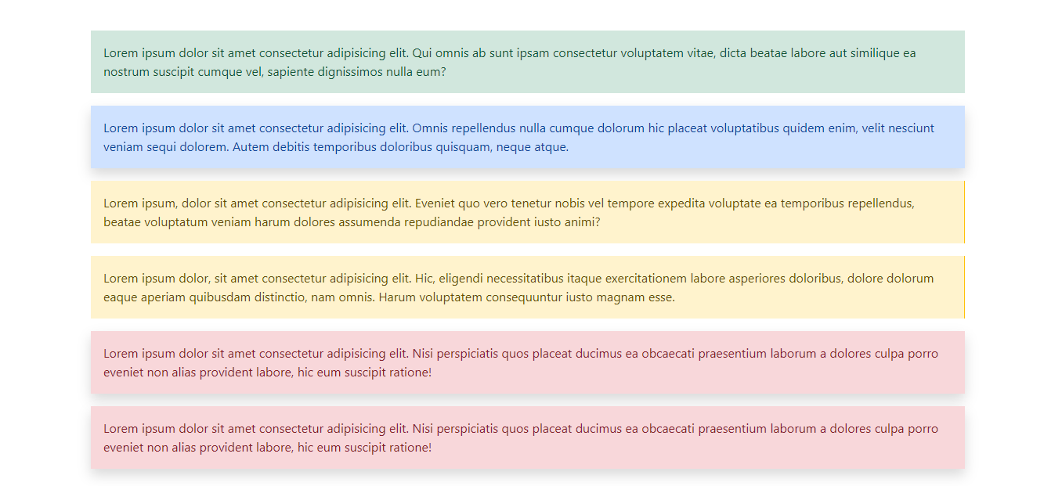

**Task no. 2:**

**Code:**

<!DOCTYPE html>

<html lang="en">

<head>

  <title>Bootstrap Example</title>

  <meta charset="utf-8">

  <meta name="viewport" content="width=device-width, initial-scale=1">

  <link href="https://cdn.jsdelivr.net/npm/bootstrap@5.3.2/dist/css/bootstrap.min.css" rel="stylesheet">

</head>

<body>

<div class="container-fluid mt-3 text-center">

  <h2>Button Styles</h2>

  <button type="button" class="btn">Basic</button>

  <button type="button" class="btn btn-primary">Primary</button>

  <button type="button" class="btn btn-secondary">Secondary</button>

  <button type="button" class="btn btn-success">Success</button>

  <button type="button" class="btn btn-info">Info</button>

  <button type="button" class="btn btn-warning">Warning</button>

  <button type="button" class="btn btn-danger">Danger</button>

  <button type="button" class="btn btn-dark">Dark</button>

  <button type="button" class="btn btn-light">Light</button>

  <button type="button" class="btn btn-link">Link</button>

</div>

</body>

</html>

**Output:**

**Task no. 3:**

**Code:**

**HTML:**

<!DOCTYPE html>

<html lang="en">

<head>

  <title>Bootstrap Example</title>

  <meta charset="utf-8">

  <meta name="viewport" content="width=device-width, initial-scale=1">

  <link href="https://cdn.jsdelivr.net/npm/bootstrap@5.3.2/dist/css/bootstrap.min.css" rel="stylesheet">

  <script src="/myScript.js"></script>

</head>

<body>

    <form>

        <div class="container-fluid mt-3 text-center">

            <h2>Calculator</h2>

            <input type="number" class="form-control" id="input1" placeholder="Enter a number">

            <input type="number" class="form-control" id="input2" placeholder="Enter a number">

            <button type="button" class="btn btn-primary" onclick="calculate()">Add</button>

            <br>

            <br>

            <div id="result" class="alert alert-primary" role="alert">

                Result will be displayed here

                <div id="addres" class="alert alert-primary" role="alert">

                    Add:

                    <p id="add"> </p>

                </div>

                <div id="subres" class="alert alert-primary" role="alert">

                    Sub:

                    <p id="sub"> </p>

                </div>

                <div id="mulres" class="alert alert-primary" role="alert">

                    Mul:

                    <p id="mul"> </p>

                </div>

                <div id="divres" class="alert alert-primary" role="alert">

                    Div:

                    <p id="div"> </p>

                </div>

            </div>

        </div>

    </form>

</body>

</html>

**JAVASCRIPT:**

**At the last of the file for all questions**

**Output:**

**Task no. 4:**

**Code:**

<!DOCTYPE html>

<html lang="en">

<head>

  <title>Bootstrap Example</title>

  <meta charset="utf-8">

  <meta name="viewport" content="width=device-width, initial-scale=1">

  <link href="https://cdn.jsdelivr.net/npm/bootstrap@5.3.2/dist/css/bootstrap.min.css" rel="stylesheet">

  <script src="/myScript.js"></script>

</head>

<body>

    <div class="container-fluid mt-3 text-center">

        <h1>Month to No of Days</h1>

        <form>

            <div class="form-group">

                <label for="month">Month:</label>

                <input type="text" class="form-control" id="month" placeholder="Enter month">

            </div>

            <button type="button" class="btn btn-primary" onclick="giveNoofDays()">Calculate</button>

            <br>

            <br>

            <div id="result" class="alert alert-primary" role="alert">

                <p id="dem" class="alert alert-danger" role="alert">

                    Result

                </p>

                <p >

                    have following days:

                </p>

                <div id="days" class="alert alert-danger" role="alert">

                    Days:

                    <p id="day"> </p>

                </div>

            </div>

    </div>

</body>

</html>

**Output:**

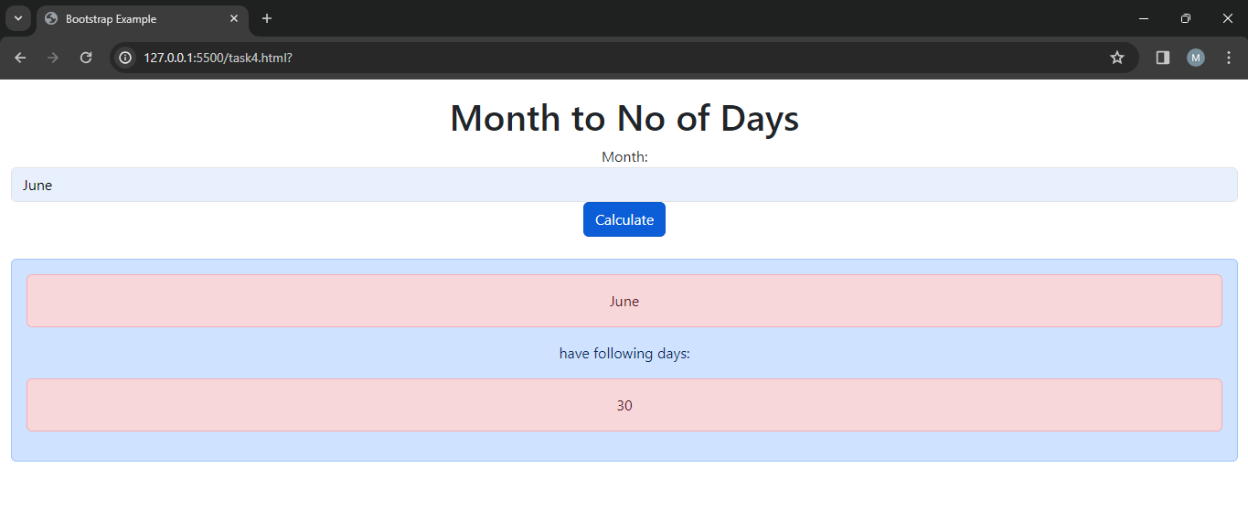

**Task no. 5:**

**Code:**

<!DOCTYPE html>

<html lang="en">

<head>

  <title>Bootstrap Example</title>

  <meta charset="utf-8">

  <meta name="viewport" content="width=device-width, initial-scale=1">

  <link href="https://cdn.jsdelivr.net/npm/bootstrap@5.3.2/dist/css/bootstrap.min.css" rel="stylesheet">

  <script src="/myScript.js"></script>

</head>

<body>

    <div class="container-fluid mt-3 text-center">

        <h1>Table</h1>

        <input type="number" class="form-control" id="number1" placeholder="Enter a number">

        <button type="button" class="btn btn-primary" onclick="printTable()">Table</button>

        <br>

        <div id="result" class="alert alert-primary" role="alert">

            <p id="dem" class="alert alert-danger" role="alert">

                Result

            </p>

            <p >

                is:

            </p>

            <div id="table" class="alert alert-danger" role="alert">

                Table:

                <p id="tab"> </p>

            </div>

    </div>

</body>

</html>

**Output:**

**JavaScript Code:**

function calculate()

{

    var num1 = document.getElementById('input1').value;

    var num2 = document.getElementById('input2').value;

    let add = parseInt(num1) + parseInt(num2);

    let sub = parseInt(num1) - parseInt(num2);

    let mul = parseInt(num1) * parseInt(num2);

    let div = parseInt(num1) / parseInt(num2);

    document.getElementById('add').innerHTML = add;

    document.getElementById('sub').innerHTML = sub;

    document.getElementById('mul').innerHTML = mul;

    document.getElementById('div').innerHTML = div;

}

function giveNoofDays()

{

    const Days= [31,28,31,30,31,30,31,31,30,31,30,31];

    const months = ['January','February','March','April','May','June','July','August','September','October','November','December'];

    let month = document.getElementById('month').value;

*for*(let i=0;i<months.length;i++)

    {

*if*(months[i] === month)

        {

            document.getElementById('dem').innerHTML = months[i];

            document.getElementById('days').innerHTML = Days[i];

*break*;

        }

    }

}

function printTable()

{

    let temp = document.getElementById('number1').value;

    let num = parseInt(temp);

*for*(let i=1;i<=10;i++)

    {

        document.getElementById('tab').innerHTML += num + " * " + i + " = " + num*i + "<br>";

    }

}